Article title
Author Name¹, Author Name² and Author Name^{1,2}
¹ Department One, Institution One, City One, Country One
² Department Two, Institution Two, City Two, Country Two

E-mail: xxx@xxx.xx

Received: xxxxxx
Accepted for publication: xxxxxx
Published: xxxxxx
Editor: aaaaaa
Abstract: This section is a very simplified version of the justification, methodology, results and contributions of the project. In the case of non- scientific manuscripts this sections simply summarizes the content of the text. It should include the most important conclusion of the study or the message that the author wants to communicate. In either case, the section should be written in less than 250 words.
Keywords: term, term, term
This work is licensed under a Creative Commons Attribution 4.0 International License

Introduction
This section provides an overview of the context or the problem authors are dealing with in the experiment and/or project explained in the manuscript. A description of the study problem should be included and why is important to treat it. Work hypotheses or tentative explanations can be added to the problem being investigated. Citations of previous works are required. Please note that all text has justified alignment (including figure captions and table titles).
This journal uses the Name Year CSE (Council of Science Editors) citation system (with few modifications, see previous volumes for reference), quite common in scientific journals. In-text citations use the last name of the author and the year of the publication, without a comma in between (e.g., Smith 2011). For two authors, their last names are separated with the word “and” (Haggarty and Gaynor 2008). For more than two authors “et al.” is used (Coyne et al. 2001). For different authors with the same last name and publication year, the initials of their names are also included (Smith BL 1999; Smith TD 1999).

Materials and methods
This section describes the methods, procedures and tools/objects used to run the project. Authors should keep in mind that readers often require details of methodological approaches to understand the limitations of the project. In the case of subheadings please use the following scheme:
Section headings: bold (just like the headings Introduction or Material and methods)
Section subheadings: non-bold italics (i.e., Sampling or Analyses)
Please use the International System of Units (https://www.bipm.org/en/publications/si-brochure/) throughout the manuscript.

Results
In this section authors need to describe the relevant data and observations that were recorded/determined to answer the main question of the manuscript. Tables and figures can be included, in which case they should be cited in the text. Do not include orphaned data (without explanation in text).
Figures should be created with an appropriate software, inserted directly and cited in the text (Fig. 1). If a plate is created, please add numbers or letters in a readable size to the different elements of the figure. If the figures are created with any vector image processing program (for example: Inkscape, Adobe Illustrator) make sure fine lines can be observed clearly. Figures can be colored, black and white or in gray tones, but please be consistent with whatever style is chosen.

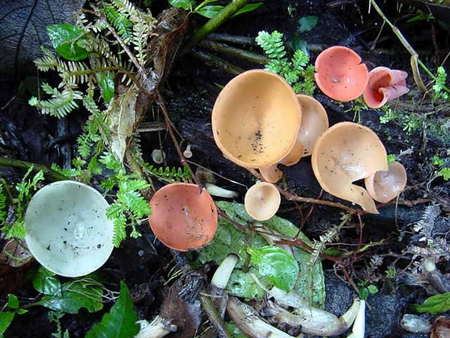
Figure 1. Example of an image. The figure caption has justified alignment.

Table 1. The title of the table should explain the contents within it and can have footnotes*. The text within the table is slightly smaller (11 pt font size) than normal text.

Type of system | First variable (units) | Second variable (units)
System A | 10 | 30±5
 | 20 | 55±7
 | 30 | 80±2
System B | 10 | 35±18
 | 20 | 70±13
 | 30 | 90±20

* The footnote of the table would go here. Also in 11 pt font size.
Tables should be constructed with the table option of the text procesor and their title should be placed on top. Try not to use the “merge and center” option unless strictly necessary. Remember the text within the table has a slighlt smaller font size (11 pt instead of 12 pt for normal text). Normally, the left column (information) has left alignment and right colum(s) representing data have centered alignment. The table should be cited somewhere in the text. No vertical lines should be included and an explicit citation of the table should be included in the text (Table 1).
Please note that if georeferences are provided, they should be given in either decimal or degree/minute/second notation (either 18.8869/-88.7711 or 18.8869N/88.7711W for the first one or 18°53'13.00"N, 88°46'16.15"W for the second one) if non-UTM coordinates are provided. In those cases, please use the “prime” and “double prime” symbols for minutes and seconds (do not use quotation marks) and in all cases please provide the elevation of the location and the datum used (in most cases WGS84). If UTM coordinates are given do not forget to add the zone of the location as in 313437.18 m E/2089251.80 m N, zone 16Q. Also, if maps are made, please provide information on the projection used for its creation.
When herbarium or collection specimens are studied, please include basic information such as the institution name, code (if it has one), and specimen or collection number. If no institutional number is available, at least provide the collector´s field book number (personal collection number). Similarly, if molecular information is provided, please include the metadata of the public repository where the basic information is (i.e., GenBank accession number).

Discussion
In this section, authors should summarize the main points of the experiment or study and link them sequentially and logically with the results obtained. It is important to briefly discuss the final message for the reader to take home. Citations of previous works are required. Remember that other researchers have generated interesting results that can be compared and contrasted here, so please include them and try to avoid citations of your own or your group work (which can generate endogamic citations) when other works can be cited.
In some cases, merging of sections is the more functional strategy for the article. For instance, in an article describing new records for a particular area, authors can simplify the first part of the article by merging the Introduction and the Material and Methods sections. Similarly, in a concise experiment, authors can simplify the second part of the article by merging the Results and Discussion sections.

Acknowledgements
Include in this section the institutions or individuals that supported the project described in the manuscript.

References (Remember to use the Name Year CSE citation style)
All cited references should be included in this section and they are arranged alphabetically and then by year. Journal names are abbreviated (see https://images.webofknowledge.com/images/help/WOS/A_abrvjt.html)

Journal reference, one author
Board J. 2001. Reduced lodging for soybeans in low plant population is related to light quality. Crop Sci. 41(2): 379-87

Stokstad E. 2019. Banana fungus puts Latin America on alert. Science 365(3450): 207-208.

Journal reference, two to ten authors
Snaphaan L, van der Werf S, Kanselaar K, de Leeuw F. 2009. Post-stroke depressive symptoms are associated with post-stroke characteristics. Cerebrovasc Dis. 28(6): 551-557.

Esquivel-Quispe R, Quispe-Ochoa JO, Hernández-Cuevas LV. 2021. Experiences on the propagation and efficacy of arbuscular mycorrhizal fungi in Latin America. J Selva Andina Biosph. 9(2): 99-108.

Books
Lewontin RC, Levins R. 2007. Biology under the influence: dialectical essays on ecology, agriculture, and health. New York (NY): Monthly Review Press.
Cepero de García MC, Restrepo Restrepo S, Franco-Molano AE, Cárdenas Toquica M, Vargas Estupiñán N. 2012. Biología de hongos. Bogotá, Colombia: Ediciones Uniandes.

Edited book
Dube OP, Sekhwela MBM. 2008. Indigenous knowledge, institutions and practices for coping with variable climate in the Limpopo Basin of Botswana. In: Leary N, Adejuwon J, Barros V, Burton I, Kulkarni J, Lasco R, editors. Climate change and adaptation. London: Earthscan. p. 71-89.

Leuchtmann A. 1994. Isozyme characterizaton, persistence, and compatibility of fungal and grass mutualists. In: Bacon C.W., White, J.F., editors. Biotechnology of endophytic fungi of grasses. Boca Raton, Florida: CRC Press. p. 21-35.

Thesis or dissertations
Walker L. 2016. Shifts in fungal community structure in selected microhabitats across nutrient treatments in a lowland tropical forest of Panama [Tesis de Licenciatura/Master´s Thesis/Doctoral Dissertation]. [City, Country]: University of Name.

Webpages
Ministry of the Environment. 2022. World natural heritage in Japan: Yakushima, Japan [Internet]. Japan: Ministry of the Environment; [visited 2022 Sep 1]. Available from: https://www.env.go.jp/nature/isan/worldheritage/yakushima/uiversal/index.html

Lado C. 2005-2021. An on-line nomenclatural information system of Eumycetozoa [Internet]. Madrid: Real Jardin Botánico de Madrid, CSIC; [visited 10 Nov 2021]. Available from: http://www.eumycetozoa.com

